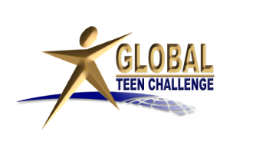
Global University (GU), the largest Distance Education Theological University in the world, and Global Teen Challenge (GTC) have forged a partnership that allows Teen Challenge centers around the world to use any of the GU evangelism and discipleship materials free of charge by simply downloading the materials from their website in English, Spanish, French and other languages. This agreement includes all of the Christian Life books that were designed for new Christians; the Christian Service books designed for more mature Christians and Christian leaders. There are also other evangelism and specific teaching materials. To obtain these free downloadable materials, go to the GU website, www.globalreach.org and choose the materials you want in your language. Most of these materials are available in multiple languages. Then download the materials and use them in any way you want. This free material will assist TC centers in
• evangelism (Great Questions of Life materials)
• the discipleship of TC students (Christian Life materials)
• to train staff and students in the later stages of the program (Christian Service materials)
Global Reach website: http://www.globalreach.org/

